**1Q. Write a shell program to find if the inputted year is leap or not.**

**Program**

root@ubuntu:~/moduleExam# ls

dbda dbda_BackUp

root@ubuntu:~/moduleExam# vim 1q.sh

root@ubuntu:~/moduleExam# cat 1q.sh

#Write a shell program to find if the inputted year is leap or not

#!/bin/bash

echo Enter a year in format YYYY

read year

if [[ year%400 -eq 0 ]]

then

echo $year is leap year

elif [[ year%100 -eq 0 ]]

then

echo $year is not a leap year

elif [[ year%4 -eq 0 ]]

then

echo $year is a leap year

else

echo $year is not a leap year

fi

root@ubuntu:~/moduleExam#

root@ubuntu:~/moduleExam# bash 1q.sh

Enter a year in format YYYY

2000

2000 is leap year

root@ubuntu:~/moduleExam# bash 1q.sh

Enter a year in format YYYY

2100

2100 is not a leap year

root@ubuntu:~/moduleExam# bash 1q.sh

Enter a year in format YYYY

2024

2024 is a leap year

root@ubuntu:~/moduleExam# bash 1q.sh

Enter a year in format YYYY

2022

2022 is not a leap year

root@ubuntu:~/moduleExam#

**OUTPUT SCREENSHOTS**

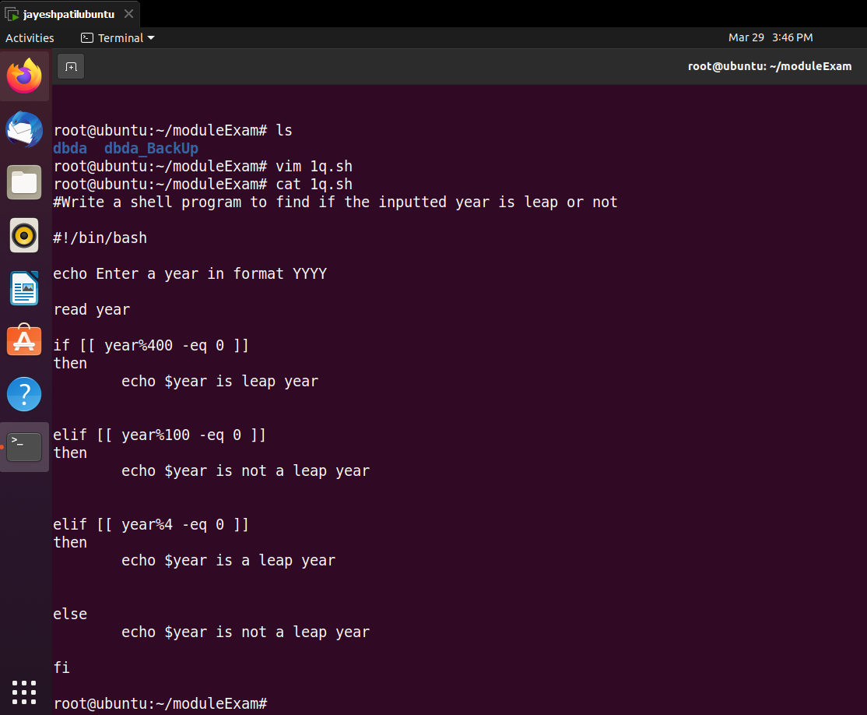

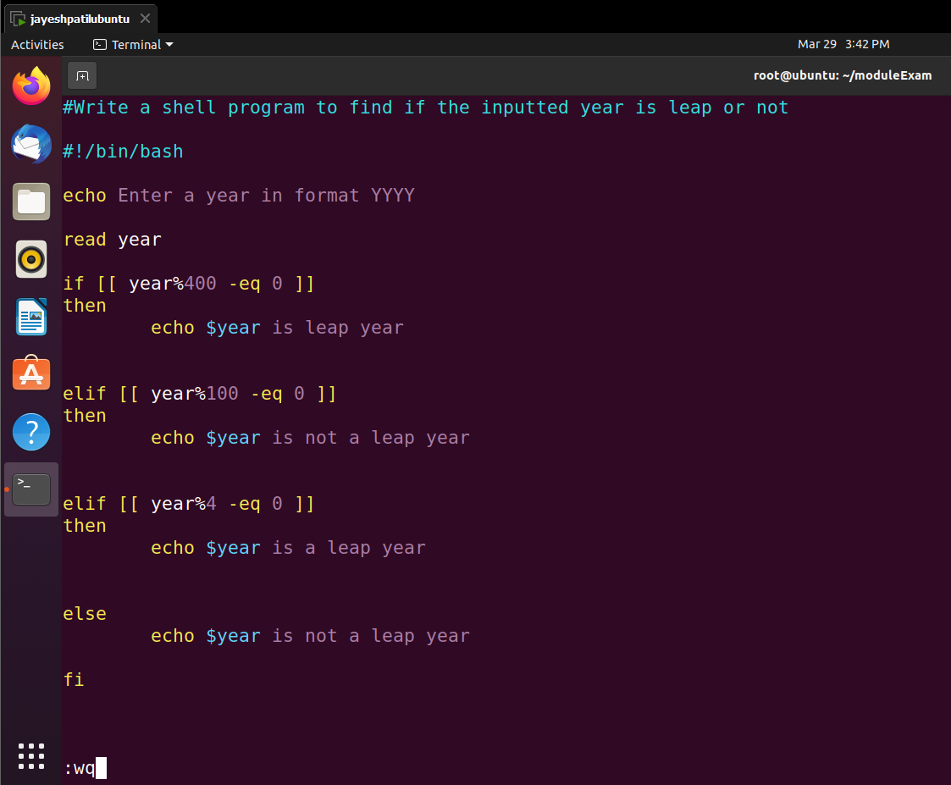

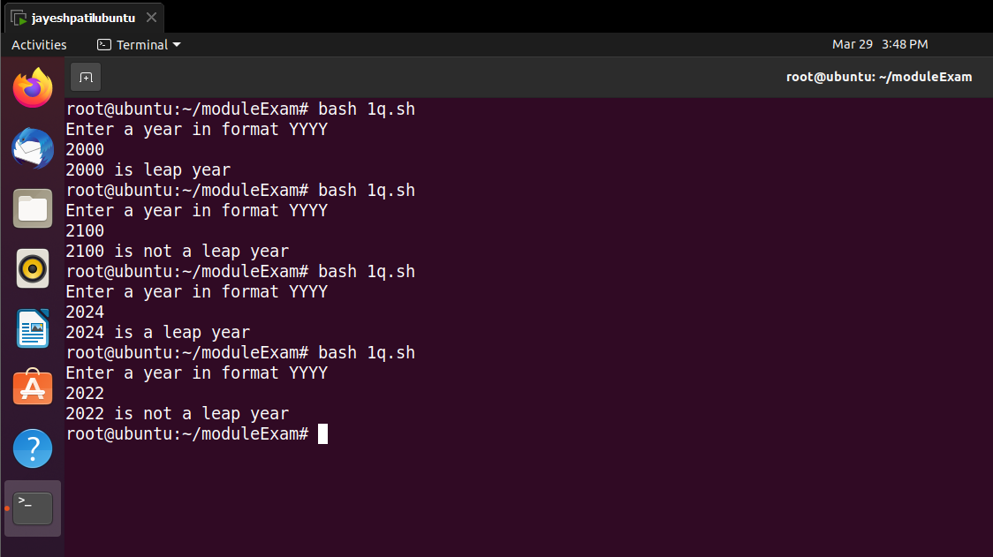

**2Q. create a user.**

root@ubuntu:~/moduleExam# touch file2.txt

root@ubuntu:~/moduleExam# ls -l file2.txt

-rw-r--r-- 1 root root 0 Mar 29 17:12 file2.txt

root@ubuntu:~/moduleExam# chmod 444 file2.txt

root@ubuntu:~/moduleExam# ls -l file2.txt

-r--r--r-- 1 root root 0 Mar 29 17:12 file2.txt

root@ubuntu:~/moduleExam#

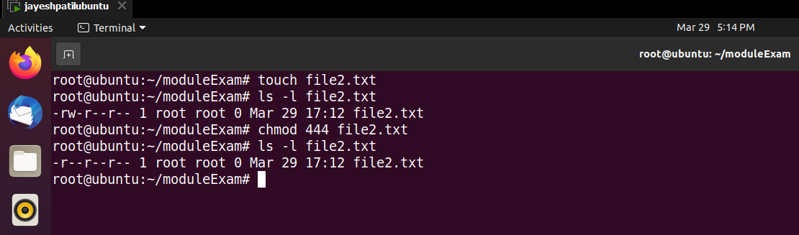

**3Q. Create a directory with name “dbda” and in the same directory create a file name Sep.txt and Perform following operation:**

**Rename the file as “Batch2.txt”**

**Move file to another directory (directory name dbda_B2)**

**Make a Backup of dbda Directory containing all the data as it is**

root@ubuntu:~/moduleExam# ls

root@ubuntu:~/moduleExam# mkdir dbda

root@ubuntu:~/moduleExam# ls

dbda

root@ubuntu:~/moduleExam# cd dbda

root@ubuntu:~/moduleExam/dbda# ls

root@ubuntu:~/moduleExam/dbda# vim Sep.txt

root@ubuntu:~/moduleExam/dbda# cat Sep.txt

PRN: 230340325016

Name: Jayesh Patil

Module End Exam : Linux and Cloud

root@ubuntu:~/moduleExam/dbda# mv Sep.txt Batch2.txt

root@ubuntu:~/moduleExam/dbda# ls

Batch2.txt

root@ubuntu:~/moduleExam/dbda# cat Batch2.txt

PRN: 230340325016

Name: Jayesh Patil

Module End Exam : Linux and Cloud

root@ubuntu:~/moduleExam/dbda# mkdir dbda_B2

root@ubuntu:~/moduleExam/dbda# ls

Batch2.txt dbda_B2

root@ubuntu:~/moduleExam/dbda# cd dbda_B2

root@ubuntu:~/moduleExam/dbda/dbda_B2# ls

root@ubuntu:~/moduleExam/dbda/dbda_B2# cd ..

root@ubuntu:~/moduleExam/dbda# ls

Batch2.txt dbda_B2

root@ubuntu:~/moduleExam/dbda# mv Batch2.txt ./dbda_B2/Batch2.txt

root@ubuntu:~/moduleExam/dbda# ls

dbda_B2

root@ubuntu:~/moduleExam/dbda# cd dbda_B2/

root@ubuntu:~/moduleExam/dbda/dbda_B2# ls

Batch2.txt

root@ubuntu:~/moduleExam/dbda/dbda_B2# cat Batch2.txt

PRN: 230340325016

Name: Jayesh Patil

Module End Exam : Linux and Cloud

root@ubuntu:~/moduleExam/dbda/dbda_B2# cd ..

root@ubuntu:~/moduleExam/dbda# ls

dbda_B2

root@ubuntu:~/moduleExam/dbda# cd ..

root@ubuntu:~/moduleExam# ls

dbda

root@ubuntu:~/moduleExam# cp -br dbda dbda_BackUp

root@ubuntu:~/moduleExam# ls

dbda dbda_BackUp

root@ubuntu:~/moduleExam# cd dbda_BackUp/

root@ubuntu:~/moduleExam/dbda_BackUp# ls

dbda_B2

root@ubuntu:~/moduleExam/dbda_BackUp# cd dbda_B2/

root@ubuntu:~/moduleExam/dbda_BackUp/dbda_B2# ls

Batch2.txt

root@ubuntu:~/moduleExam/dbda_BackUp/dbda_B2# cat Batch2.txt

PRN: 230340325016

Name: Jayesh Patil

Module End Exam : Linux and Cloud

root@ubuntu:~/moduleExam/dbda_BackUp/dbda_B2#

Output Screenshot:

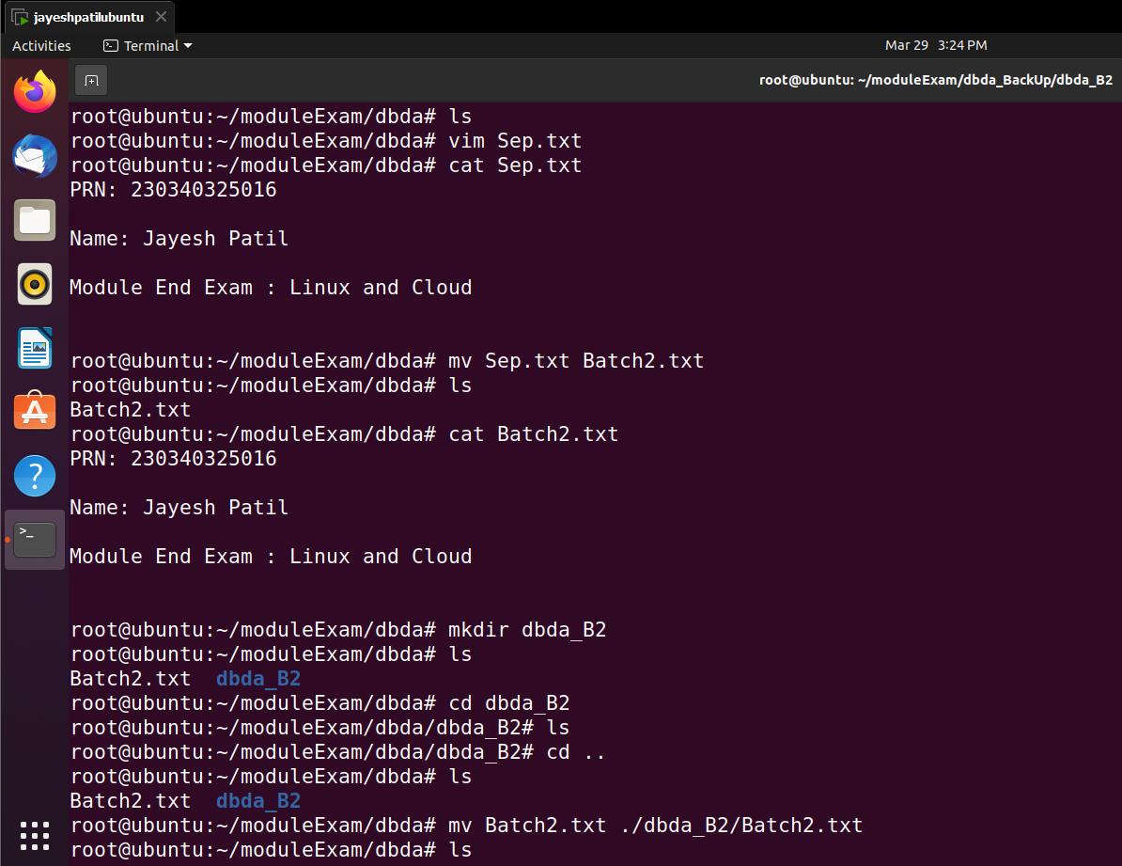

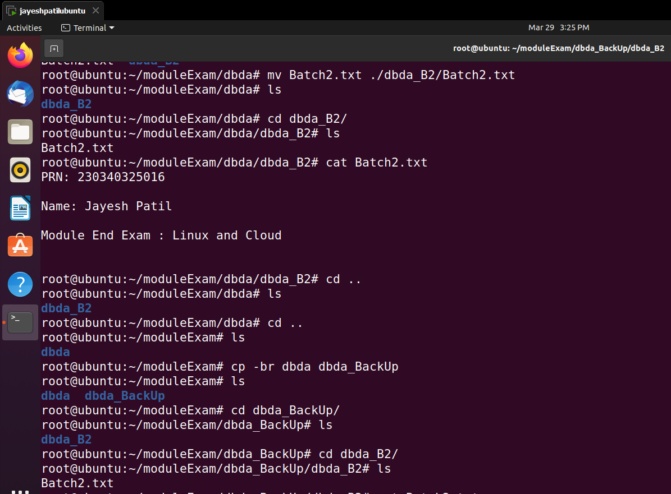

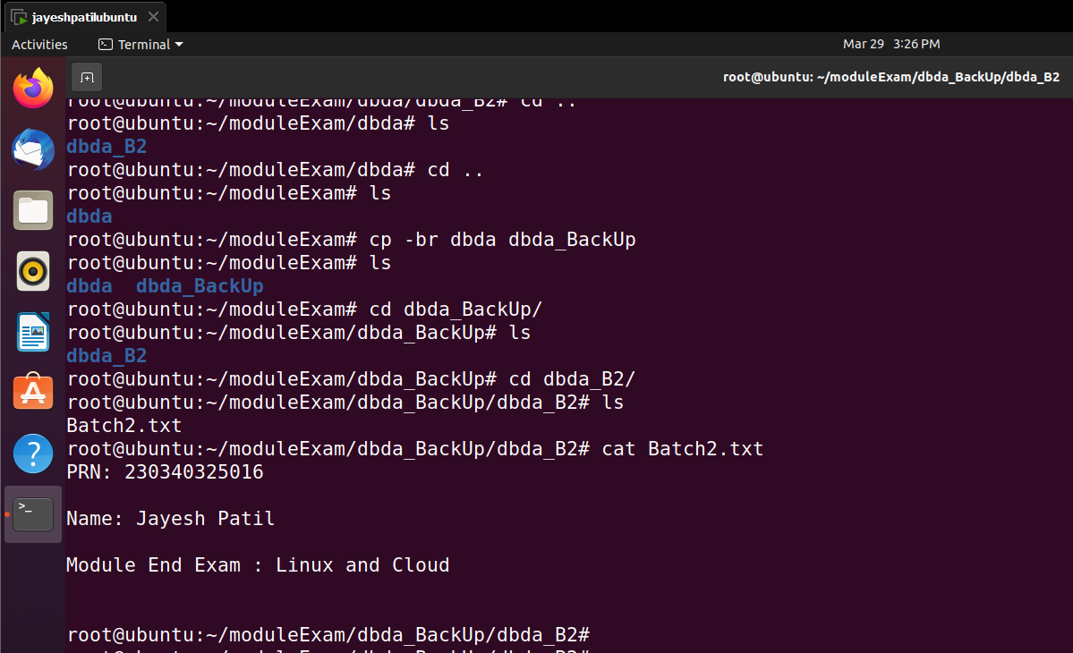

4Q. Create a Linux EC2 and access the EC2

